Camellia Connection Summer/Fall 2022

Newsletter of Camellia District IV - The Garden Club of Georgia, Inc.

Camellia Connection Winter Issue Deadline: January 1, 2023
Send your Garden Club News and photos to Lindsay Day at leboren@gmail.com

2021-2023 Camellia
Director’s Message

District Executive Board Dear Classy Camellias,

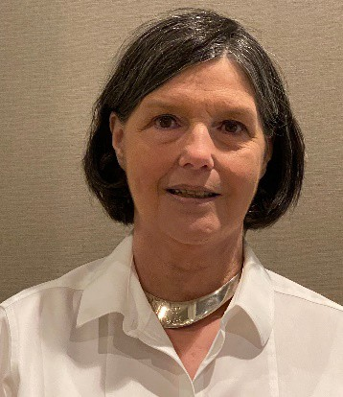

Director
Rita Hightower

Co-Director Cathy Perry

Recording Secretary Vicki Johnson

Corresponding Secretary Lindsay Day

Treasurer Suzan Bennett

Assistant Treasurer Annelle Moore

Parliamentarian Anita Allen

Advisor Jan Thiese
Hope you all are weathering the heat and having a great summer so far. Things have been quiet since the convention, but a lot of things have been happening.

After being on the job for less than two weeks, our new office person at headquarters in Athens decided that the job was not a fit for her. Our employment committee is now, once again, in the hunt for a new person to manage the office. This is a very time consuming and tedious job. Please keep our committee in your thoughts and prayers as they seek to find the right person for this job. Not having someone in headquarters has slowed down the flow of informaton and statistics that we use and need. Please bear with all of us as we try to maneuver this trying time.

The Annual State Convention in Macon was great. Interesting speakers, good meals, great fellowship, and, of course, awards. Camellia District had a few outstanding awards, especially for the Thomasville Clubs and the Dublin Clubs. If you have never attending a State Convention, I encourage you to plan on attending in April of 2023. The meeting will be held in Stone Mountain, Georgia. Not only will you be attending an outstanding meeting, but you will get to see a part of history as well. Information for this event will be coming out after the first of the New Year.

Our next event is in Tifton for the August Board Meeting. The call letter will be going out very soon. Please make plans to attend. We have several things to vote on. It is important for our officers, committee chairmen, and other voting representatives be there. The District belongs to everyone and each club should have a say in the way we do business.

Committee Chairmen, please have your reports to me no later than August 1st. The meeting will be held August 9th and we look forward to hearing your in person reports.

One of the things we will be voting on is to try to prepare for a flower show school in our district. Judges for flower shows are becoming fewer and fewer. If flower shows are to remain a part of our clubs, we need judges to judge them. To put on this school is very costly. However, we have several avenues of thought on how to move forward and to help cover the cost for the school and hope to see some of our own district clubs participate.

In March, Valdosta Council, along with the Coastal Plain Native Plant and Wildflower Society, held a symposium in the reception hall of The Crescent in Valdosta. Approximately 90 people attended.
This event, for many years, was sponsored by UGA Tifton and the CPNPWS. However, the University of Georgia has discontinued its support of this program. We were all searching for a way for the event to continue and, for this year only, it was sponsored by Valdosta and CPNPWS.

I have been approached by CPNPWS about Camellia District continuing helping them in carrying out this program. They will pay for the space, take on all aspects of the event except for finding a location, and making breakfast and lunch available. Everyone would pay for their lunch, but breakfast items, coffee, water, etc. would be the host club’s expense. This proposal will also be voted on at the August 9th meeting for presentation at the Annual Meeting.

Our annual District meeting for this year will be held in Douglas, Georgia on October 13th. Sarah Evans is heading up this event. and we are excited to be going there. Information can be found in this issue of the Camellia Connection and more will be sent later in the summer. Please make plans to attend. Our State President and the other district directors, as well as other state officers will be in attendance. Please mark your calendars and plan to join us for a great meeting.

One of the officers in attendance will be Diana Malone, our new awards chairman. She will be there to answer questions and to offer help with awards. This is a good time to tap into the knowledge of Diana. She is more than willing to be of assistance.

As always, thank you for helping making our district strong. We would not be here if it were not for you. We can do nothing without you.

Blessings,
Rita

