The Azalea Trumpet

Spring 2023

A publication of the of The Garden of Georgia, the Deep South Region, and the National Garden Club

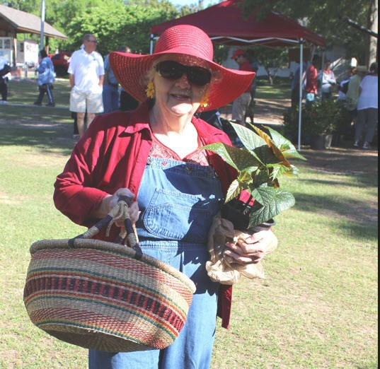
Director’s Message
Betty Davis
Spring has arrived and it has been spectacular. Something beautiful appears each day.
Summer is just around the corner. Seasons change and so must we. Some changes are difficult, but others are exciting. You have elected new Officers for Azalea District and this is a good change. District Director Elect, Jane Edmunds and the executive officers will be installed along with the new GCG officers at the GCG Convention in Stone Mountain and I hope many Amazing Azaleas plan on attending. We will have a
farewell reception for THE AMAZING AZALEA PEGGY TUCKER of whom we are all so proud .

It has been an Amazing term for me with the help of so many Azalea members. We teed off in Augusta and have played together for two years to Plant America and promote Beautification, Conservation and Education. There have been challenges and changes, but we have emerged to beauty and even played under Par!


Azaleas have had two Annual Fall Meetings, one on Zoom and an outstanding exquisite one in Athens. Four
Board meetings from golfing in August 2021, to a Presiden- tial Luncheon in Norwood, February 2022, then a Summer Flower Garden with Betty’s Butterflies in Union Point, Au- gust 2022 and ending with a fun, fun, fun Flutter by Mardi Gras in Sandersville, February 2023.

I have attended two GCG Conventions, one on Zoom in April 2021 and the other in Macon in April 2022. In May Azaleas District Hosted the Historic Preservation Fundraiser in Milledgeville. It was a unique outdoor luncheon and

lecture followed by a tour of Lockerly Arboretum and Rose Hill Mansion. Attendees came from all over the State. The next day I headed to Orlando, FL for the NGC Convention.

I have traveled throughout the state of Georgia on roads and in areas I have never seen before. My favorite visits have been to many Azalea Garden Clubs to enjoy the special programs and events – Anniversaries, Blue and Gold Star Marker Dedications, First Ladies Ca- mellias dedication, the Porcelain and Decorative Art Museum Ribbon cutting and dedication, a fabulous Nativity display in Louisville and the Ribbon cutting at the Azalea Walk at Pend-
leton King Park, I have installed officers, judged a daylily horticulture show and recently went to two 3rd grade classes at an elementary school dressed as Fraidy Frog and read them “The Frightened Frog” book.

On a sad note I attended several funerals and celebration of life memorials of some very special friends and family and I miss them greatly. Thank all of you who sent me uplift- ing sympathy notes, cards and a couple of Penny Pines memorials. This year I received 40 President’s reports and realized why so any counties and cities, schools and parks look so pretty -- Azaleas have truly worked and played outdoors to Plant America and have made Azalea District of Georgia a beautiful place to live.

I want to thank the members of the Azalea Executive Committee for their support and for being the “wind beneath my wings” that has kept me going these past two years. I also
thank all Azalea Board members for faithfully fulfilling your positions and reporting at
meetings or on line your advice and encouragement to District members. Last but not least I thank all “Amazing Azalea” Club members for continuing to work through the changes and challenges to keep your clubs together. Thank each and every club member who bought GCG lottery tickets. As of March 30th Azalea District is ahead of all 7 districts purchasing 729 tick- ets. The closest district to us is Camellia with purchase of 435 tickets. Way to go Azalea Club members!!


2021
2023
Now I leave you with this Irish blessing:
May your heart be light and happy, May your smile be big and wide and May your pockets always have a coin Inside..
For each petal on the shamrock this brings a wish you way,
Good health, good luck and happiness for today and every day!
Betty Davis


Job well done Betty, we will miss you!




Mary Helen Brooks Carter
April 16, 1930—February 23, 2023

Nancy Hart Garden Club shares the loss of long-time Nancy Hart Gar- den Club member Mary Helen Brooks Carter. Mary, or Mrs. William
O. Carter, loved life and was active throughout her life in the Hartwell Community and her church, Hartwell First United Methodist Church.
She participated in several early productions of the Hart County Community Theater, was a member of the Ladies Golf Association, and served as secretary for both her UMW Circle
group and our garden club for many years. She was a member of the DAR and recently retired from the Hart County Library Board after 20 years of service. Mary enjoyed playing bridge and in later years pursued her love of travel, taking many wonderful trips with The Fun Club and her church. Mary won our hearts with her love of gardening, her quick wit, and her heart of service. Here are a few of her garden club distinctions:
- 1963 – 1964, Past President of the Nancy Hart Garden Club
- 1980 - 1981, Past President of the Nancy Hart Garden Club
- February 3, 1999, State Life Member
2022 – her death in 2023, Honorary Member of the Nancy Hart Garden Club
We will miss Mary’s zest for life, twinkling eyes, and dedication to her faith, family, friends,

Many people will walk in and out of your life, but only true friends leave footprints in your heart. — E L E A N O R R O O S E V E L T

If your Club should lose a member to death, please notify Mary Byrd, Chaplain, at maryb328@att.net.



 a  On Our M

“In every gardener, there is a child who believes in the seed fair .”

Rose and Dahlia Garden Club Puts Spotlight on Becky Green

Becky Green leads the volunteer committee from Rose and Dahlia Garden Club who engage students of Downtown Academy once-a- month in an after-school garden club program. Becky selects the theme and prepares interactive projects for the students to com- plete. Rose and Dahlia Garden Club members assist with setting- up, completing art projects, providing refreshments, and cleaning up.

sonal flowers.
Becky was instrumental in connecting DtA with a club at Athens Academy who built a bench for teachers to use during recess. The AA club also built raised beds for the Growing Seeds Garden Club. Becky secured large pots for the entrances to the school in which the Growing Seeds Club members plant fall and spring with sea-

Since October, Becky’s programs have offered lessons on recycling, life cycle of the pumpkin seed, poinsettias, cardinal care, and floral design. Becky and Garden Therapy Chairman Anne Lane have forged a bond between the students at Downtown Academy and the residents of
Terra Bella Senior Living. Wile they do not meet together, they have exchanged valentines. The students enjoying making floral arrangements to be delivered to Garden Club members at Terra Bella.


Becky Green has led our Growing Seeds Garden Club since 2019. Becky also serves as the Azalea District Youth Coordinator. Rose and Dahlia earned the Katherine S. Allen Youth Ac- tivities Award at the Azalea District Fall Annual Meet-
ings in 2022 and 2020. The Azalea District School Grounds Improvement Award was awarded to Rose
and Dahlia in 2021. Thank you, Becky, for everything you do for Rose and Dahlia Garden Club and the stu- dents of Growing Seeds Garden Club at Downtown Academy.

Chairman Reports

Planting and Growing with Challenges
Gardening Issue: Linda Doiron,

Ferns for the New Year

Ferns can symbolize new beginnings in many ways. Some cultures believe that ferns have magical properties and can help people find hidden treasures. Some believe they have medicinal value and can be associated with prosperity, long life, and good luck.
Thus, I thought a deep dive into ferns would be a great way to end 2022, and to cele- brate the beginning of the new year.
Ferns are often prized for their aesthetic appeal because they can add a touch of green- ery and natural beauty to any environment. Some ferns have delicate lacy fronds that create a graceful look, while others have broad bold fronds that give them a more sub- stantial presence. They can be used in a variety of settings, both indoors and outdoors, to add visual interest and can either be used as standalone plants or incorporated into
large displays. Ferns are also prized for their ability to purify the air and improve the overall quality of indoor environments.
If you're looking for indoor container ferns that will be perfect for your home or apart- ment, consider the Boston fern (Nephrolepis exaltata), staghorn fern (Platycerium), bird’s nest fern (Asplenium nidus), maidenhair fern (Asiatum) or button fern (Pellaea rotundifo- lia). It is important to choose a pot that has good drainage and use a well-draining potting mix when growing small indoor ferns. Keep them out of direct sunlight to avoid scorching the fronds.
Did your potted fern freeze during the recent cold snap? You may not be able to save every frozen frond, but if the roots survive, your fern has a chance. Here are some tips to provide the correct care and minimize recovery time. Move your potted fern into a protected cool frost-free area as soon as possible to minimize further damage. Water the potting soil thor- oughly to hydrate the roots and keep out of direct bright sunlight to prevent further dam- age. If you want to check for frost-damaged roots, lay the container on its side and wiggle
the fern loose. Hold it by the root ball and cut off all the frost-damaged roots (black and mushy), and then repot with fresh potting soil. If your roots are black all the way through the fern will not recover.


Finally, ferns are inexpensive, eco- friendly, healthy and can provide a quick pick-me-up up during the
winter while we wait to plant out- doors
in spring. Happy New Year and best wishes for a happy and healthy year ahead to all in our gardening family!

Indoor Ferns
Top Left: Boston Fern
Bottom Left: Maidenhair Fern Top Right: Staghorn Fern Middle Right: Bird’s Nest Fern Bottom Right: Button Fern

Woodland Ferns
Woodland Ferns grow with a great variation in size, texture, color,
spread, shape and year-round inter- est. Most are perennial and they don't propagate by seed, but instead they reproduce via small dots on the underside of the frond called spores, or by layering and attaching the sto- lon on soil, a long fuzzy string like
structure growing from your frond.

Most ferns thrive in shady areas where they can get consistent mois- ture so look to add them in your woodland garden. While many are different shades of green, several ferns can be different colors.

TL: Southern Shield Fern TR: Autumn Fern
TL 2: Holly Fern CR: Japanese Painted Fern
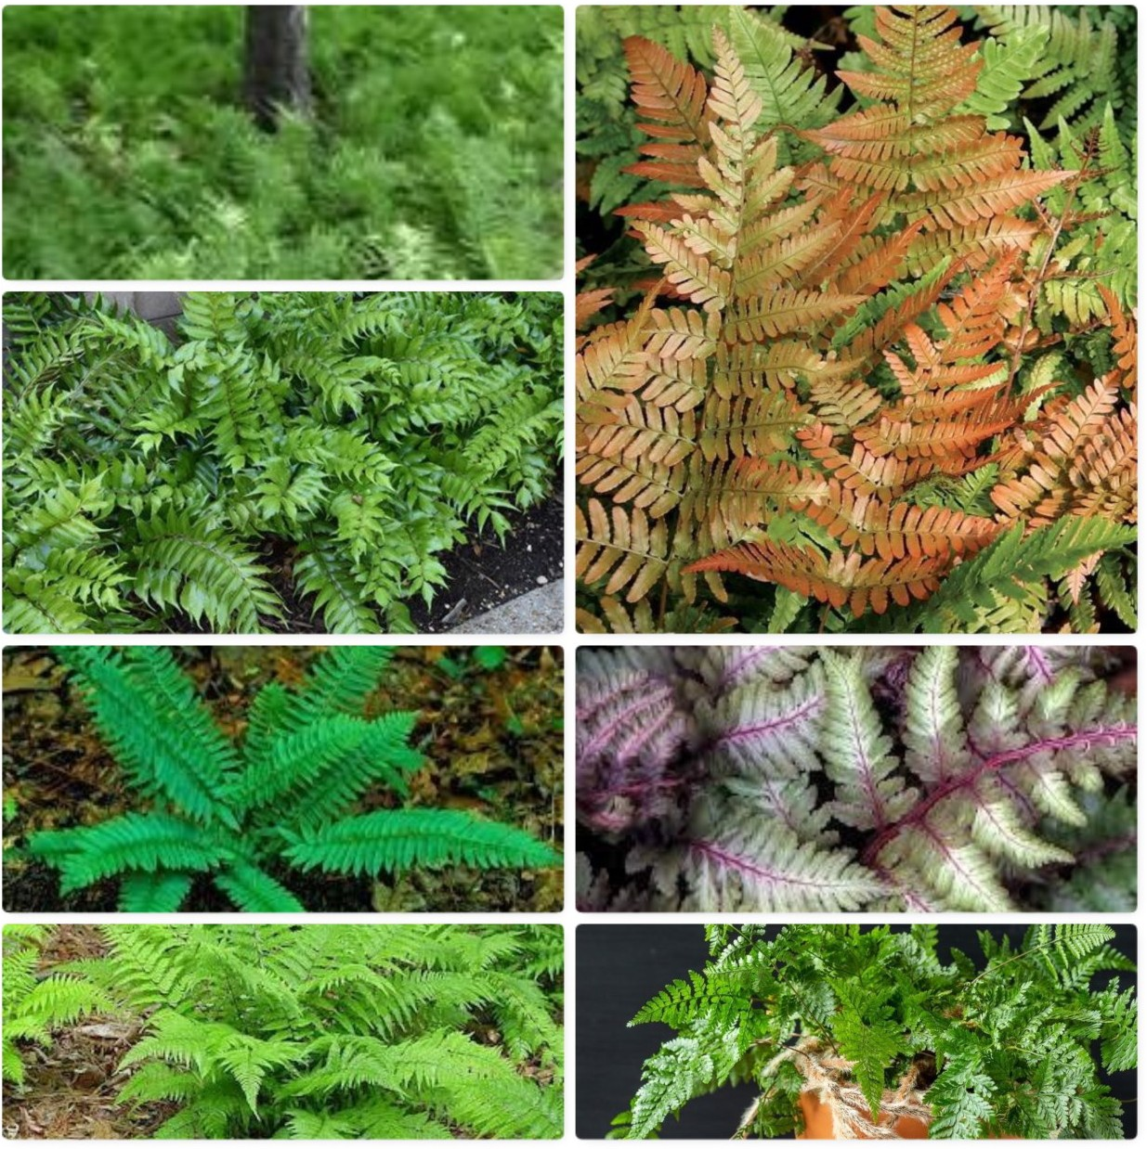
TL3:Chritmas Fern BR: Rabbit's Foot Fern

Jan Thiese, Blue Star & Gold Star Markers Chairman The Garden Club of Georgia, Inc.



As expected, I have received new pricing for the Blue and Gold Star Markers from Sewah Studios. It
is as follows:

Blue/Gold Star Pricing
Pricing Effective May 1st, 2023 good thru May 1st, 2024

Marker, post, shipping | $1,995.00
Byway Plaques | $665.00
Replacement Posts | $375.00
Refurbishment | $1200.00 *

*At the current time, Tom Stelling still only charges $750.00 to refurbish/restore a marker on site. I would suggest checking on your markers and if restoration is needed, give Tom a
call. He’ll be heading back our way soon.
His contact number is (386) 299-7841. Keep in mind that there is GCG Grant Money available to help pay for restorations.
If your club has been considering sponsoring a Blue or a Gold Star Marker, I would encourage you to try and get you orders in to me by April 17 to assure that the order is received by Sewah Studios before the May 1st price increase.
Feel free to contact me for assistance or with any questions. Jan Thiese
128 Weatherby Drive Macon, GA 31210
janicemariemaconga@cox.net
(478) 319-4234 Cell




Virginia Allen, Chm Pull Tabs for Ronald McDonald House Project

Thank you to the 26 Azalea District Garden Clubs who collected 371 lb. 14 oz of pull tabs for the Ronald McDonald house during the past year. Money from recycling the tabs is used to supplement programs for fami- lies staying at the house in Augusta. I have enjoyed being your pull tab chairman since 2012 and am retiring from that position at the
end of March. Please continue to support this worthwhile project and your new pull tab chairman.



AZALEA DISTRICT PULL TAB TOTAL For April 2022- March 2023
26 Clubs collected 371 lb. 14 oz of pull tabs for Ronald McDonald House
Virginia Allen, Azalea District Pull Tab Project Chairman 2916 Westchester Drive, Augusta, GA 30909
706-736-6793, vallenotr@aol.com

2nd qtr. 2022 none

3rd qtr. 2022: Yearly Total:

8/24/22 Carrington Woods GC | 44 lb. | 8 oz | 44lb 8 oz
8/24/22 Greensboro GC | 10 lb. |  | 11 lb. 15 oz
8/24/22 Ladies GC |  | 8 oz | 1 lb. 7 oz
8/24/22 Milledgeville GC | 7 lb. | 15 oz | 7 lb. 15 oz
8/24/22 Nancy Hart GC | 30 lb. | 3 oz | 46 lb. 13 oz
8/24/22 Pine Tree Hartwell GC | 49 lb. | 8 oz | 56 lb. 14 oz
8/24/22 Rose and Dahlia GC | 10 lb. | 1 oz | 10lb 1 oz
8/24/22 Town and Country Sandersville |  | 13 oz | 13 oz
8/24/22 Union Point GC | 6 lb. | 7 oz | 6 lb. 7 oz
8/24/22 Warrenton GC | 1 lb. | 1 oz | 1 lb. 1 oz
8/30/22 Pine Tree Hartwell | 2 lb.
9/16/22 Pine Tree Hartwell | 5 lb. | 6 oz | 7 lb. 6 oz
9/17/22 Monroe GC | 11 lb. |  | 11 lb.
9/22/22 Madora GC | 64 lb. |  | 64 lb.
9/24/22 Gateways GC |  | 15 oz | 5 lb. 2 oz
4th qtr. 2022: none

1st qtr. 2023
2/21/23 Gateways GC | 4 lb. | 3 oz
2/21/23 Greensboro GC | 1 lb. | 15 oz
2/21/23 Ladies GC |  | 15 oz
2/21/23 Rose and Thyme GC | 1 lb. | 9 oz | 1 lb. 9 oz
2/21/23 Sandersville GC |  | 10 oz | 10 oz
2/21/23 Sharon Raytown GC | 1 lb. | 15 oz | 1 lb. 15 oz
2/28/23 Nancy Hart GC | 16  lb. | 10 oz
2/28/23 Midville Garden Club | 19  lb. | 12 oz | 19 lb. 12 oz
17 clubs (non-ACGC) collected 291 lb. 14 oz

2022 - 2023 Pull Tab Record for clubs in ACGC
2nd qtr. 2022– none

3rd quarter 2022

8/6/22 Spade and Trowel GC | 18 lb.
9/1/22 Spade and Trowel GC | 1 lb. | 10 oz
9/6/22 Cherokee Rose GC |  | 10 oz
9/19/22 Pine Needle Lin- colnton | 20 lb.
9/22/22 Iris GC |  | 3 oz
9/25/22 Grovetown GC | 6 lb. | 6 oz
9/25/22 After Six GC | 1 lb. | 14 oz
9/26/22 Cherokee Rose GC | 17 lb.
4th quarter 2022
10/6/22 Pine Needle Augus- ta |  | 5 oz
11/1/22 Cherokee Rose GC |  | 3 oz
11/8/22 Spade and Trowel GC | 1 lb. | 2 oz
12/6/22 Cherokee Rose GC |  | 3 oz
1st quarter 2023

1/26/23 Greenbrier GC | 2 lb. | 11 oz
1/26/23 Magnolia GC | 1 lb. | 3 oz
1/26/23 Spade and Trowel GC |  | 8 oz
2/6/23 After Six GC | 2 lb. | 6 oz
2/7/23 Iris GC | 4 lb.
2/13/23 After Six GC | 1 lb. | 9 oz
3/7/23 Cherokee Rose GC |  | 3 oz
ACGC Totals by club as of 3/17/23

After Six | 5 lb. | 13 oz
Cherokee Rose | 18 lb. | 3 oz
Greenbrier | 2 lb. | 11 oz
Grovetown | 6 lb. | 6 oz
Iris | 4 lb. | 3 oz
Magnolia | 1 lb. | 3 oz
Pine Needle Augusta |  | 5 oz
Pine Needle Lincolnton | 20 lb.
Spade and Trowel | 21 lb. | 4 oz


The Garden Club of Georgia, Inc. announces the Youth Contest Award
Winners for 2023 in Essay, Poetry, Sculpture, and Poster Contests.

SCULPTURE

4th Grade:
1st Aniyah – Honey Creek Elementary, Co- nyers, GA
2nd Julia – Arnold Mill Elementary School
3rd Ariana– Flat Shoals Elementary School.
5th Grade:

1st Place: Brynn

ESSAY
1st Jaden - Peachtree Elementary.
2nd Logan – Screven Co. Elementary School 3rd Zoey – Pine St. Elem. – Conyers, GA
6th Grade:
1st Place – Ella -Scrreven County Middle School 2nd Place – Sha’more – Screven County Middle
School.
3rd Place – Sanyah – Screven Co. Middle School.
7th Grade:
1st Place – Layla-Coleman Middle School.
2nd Place – Michael – Summerour Middle School.


Northwoods Garden Club Camellia District
2nd Place:
Avery
Magnolia Garden Club (Cartersville) Laurel Dis- trict
3rd Place:
Gianna
Spade and Trowel Garden Club (Augusta) Azalea District



POETRY

R Educat on

Kindergarten
1st Mackenzie ,Conyers Garden, Redbud D s
1st Grade
1st Elijah, Gateways Garden Club (2-435), Azalea D s 2nd Kye, Odum Garden Club (3-230), Oleander D s 3rd Zellie, Odum Garden Club (3-230), Oleander D s 2nd Grade
1st Jace, Beautiful View Garden Club (5-145), Magnolia D s 2nd Demery, Spade & Trowel Garden Club (2-245), Azalea D s
3rd Kaitlyn, Camellia Garden Club (5-340), Magnolia D s r
3rd Grade
1st Isla, Briarcliff Garden Club (4-425), Camellia D s 2nd Alana, Camellia Garden Club (5-340), Magnolia D s 3rd Madison, Conyers Garden Club (7-170), Redbud D s 4th Grade
1st Bebe , Magnolia Garden Club (3-045), Oleander D s 2nd Liam, Spade & Trowel Garden Club (2-245), Azalea D s 3rd Jordai’, Briarcliff Garden Club (4-425), Camellia D s
5th Grade:
1st Brooklyn, Beautiful View Garden Club (5-145), Magnolia District 2nd Alison, Roswell Garden Club (6-620), Dogwood District
3rd Abigail, Briarcliff Garden Club (4-425), Camellia District
6th Grade:
1st Michael, Camellia Garden Club (5-340), Magnolia District
7th Grade:
1st Sierra, Camellia Garden Club (5-340), Magnolia District 2nd Ashton, Camellia Garden Club (5-340), Magnolia District 3rd Kaylie, St. Marys Garden Club (3-640), Oleander District
8th Grade:
1st Sasha, Briarcliff Garden Club (4-425), Camellia District
2nd Evan, Southern Lily Garden Club (4-543), Camellia District

SN Educat on

Kindergarten
1st Linlee , Odum Garden Club (3-230), Oleander D s
1st Grade
1st Creed, Odum Garden Club (3-230), Oleander D s 2nd Warner, Odum Garden Club (3-230), Oleander D s 2nd Grad
1st R. J., Odum Garden Club (3-230), Oleander D s
2nd Beau Ogdon, 7, Odum, Odum Garden Club (3-230), Oleander D s
3rd Grade
1st Morgana, Odum Garden Club (3-230), Oleander D s 2nd Carter, Odum Garden Club (3-230), Oleander D s 4th Grade
1st De’Asia, Briarcliff Garden Club (4-425), Camellia D s 2nd JaDerrick, Briarcliff Garden Club (4-425), Camellia D s
3rd Wyatt, Odum Garden Club (3-230), Oleander D s r
5th Grade

1st Myrah, Pine Forest Garden Club (3-025), Oleander D s

2nd Elias, Pine Forest Carden Club (3-025), Oleander D s

ESOL English as a Second Language

1st Grade:
1st Lilly, Odum Garden Club (3-230), Oleander District 2nd Abby, Odum, Odum Garden Club (3-230), Oleander District
2nd Grade:
1st Celine, Odum Garden Club (3-230), Oleander District 2nd Joselyn, Odum Garden Club (3-230), Oleander District 3rd Grade:
1st Isaac, Odum Garden Club (3-230), Oleander District
2nd Abram, Pine Forest Garden Club (3-025), Oleander District
4th Grade:
1st Alonzo, Pine Forest Garden Club (3-025), Oleander District 2nd Kenlee , Pine Forest Garden Club (3-025), Oleander District 5th Grade:
1st Sophia, Odum Garden Club (3-230), Oleander District
2nd Mariangelis, Briarcliff Garden Club (4-425), Camellia District
3rd Israel, Pine Forest Garden Club (3-025), Oleander District

POSTERS: Woodsy Owl

Lilly
Briarcliff Garden C ub Thomasvi e Camellia D s
Grade 1: First P ace

Marvin
Lily Garden C ub S reven Oleander D s
Grade 1: Second P a e

Jackson

Lily Garden C ub S reven Oleander D s

Kristeena
Spade & Trowel Garden C ub
Augusta Azalea District Grade 3 First P a e

LynnLeigh
Ruby Riggins Camellia Garden C ub
esup
Oleander D s
Grade 3: Second P a e

Jules
Spade & Trowel Garden C ub Augusta
Azalea D s
Owens
Pine Needle Garden C ub
Lincolnton Azalea District Grade 4 First P a e

America
Lily Garden Club
S reven
Oleander D str t Grade 4: Second Pla e

Patton
Lily Garden Club S reven
Oleander D str t
Grade 4: Third Pla e

Lucy
Watkinsville Garden Club Watk nsv lle
Azalea D str t Grade 5: First Pla e

Leona
Magnolia Garden Club Moultr e
Camellia D str t Grade 5: Second Pla e

Bronx
L ly Garden Club S reven
Oleander D str t

Faith
Jesup Garden C ub esup
Oleander D s Grade 1: First P ace

Hardee
Jesup Garden C ub esup
Oleander D s
Grade 1: Second P a e

Janay
Camellia Garden C ub
Cuthbert Magno a District Grade 1 Third P a e

Raegan
Jesup Garden C ub esup Oleander D s
Grade 2: First P a e

Chloe
Camellia Garden C ub Cuth- ber
Magnolia D s r
Grade 2: Second P ace

Avery
Odum Garden C ub Odum
Oleander D s
Grade 2: Third P a e

Grant
Spade & Trowel Garden C ub Augusta Azalea District

POSTERS: SMOKEY BEAR
Eli
Camellia Garden C ub Cuthber
Magnolia D s r
Grade 3: Second P a e

Redbud D str t
Grade 5: Second Pla e

Sammy
Jesup Garden Club Jesup
Oleander D str t Grade 5: Third Pla e

Kate
Green Thumb Garden C ub Thomaston Redbud District
Grade 3 Third P a e

Freya
Spade & Trowel Garden C ub
Augusta Azalea District Grade 4 First P a e

Avalynn
Pine Needle Garden Club L n olnton
Azalea D str t
Grade 4: Second Pla e

Jaxon
Lily Garden Club S reven
Oleander D str t
Grade 4: Third Pla e

Allison
Roswell Garden Club Roswell
Dogwood D str t Grade 5: First Pla e

Keaton
Green Thumb Garden Club
Thomaston
Redbud D str t
Grade 5: Second Pla e

Sammy
Jesup Garden Club Jesup
Oleander D str t Grade 5: Third Pla e



News from Our Clubs

Nancy Hart Garden Club (Hartwell) Receives H4H Grant
The Azalea District Executive Committee recently awarded a $500 grant to Nancy Hart Gar- den Club (Hartwell) for their Habitat for Humanity project to install landscaping at a newly constructed H4H home in Hart County. The plantings will consist of 10 evergreen shrubs – five on each side of the property boundary. The design includes a fig tree for the backyard.
Red Diamond Loropetalums, Breeze Lomandras, Persian Shield Strobilanthes and assorted annual primrose flowers will fill the beds on either side of the front steps. Pictures will be published in a later edition of Azalea Trumpet.
Funds remain in the Azalea District account specified for Habitat for Humanity projects. If your club is interested in partnering with your Habitat for Humanity affiliate, and you need funds to complete the project, reach out to Azalea District H4H Chairman Ina Hopkins for ap- plication forms. When projects are completed, a report form found on the GCG website must be submitted.



Azalea District Board meeting February 21, 2023
Sandersville, GA

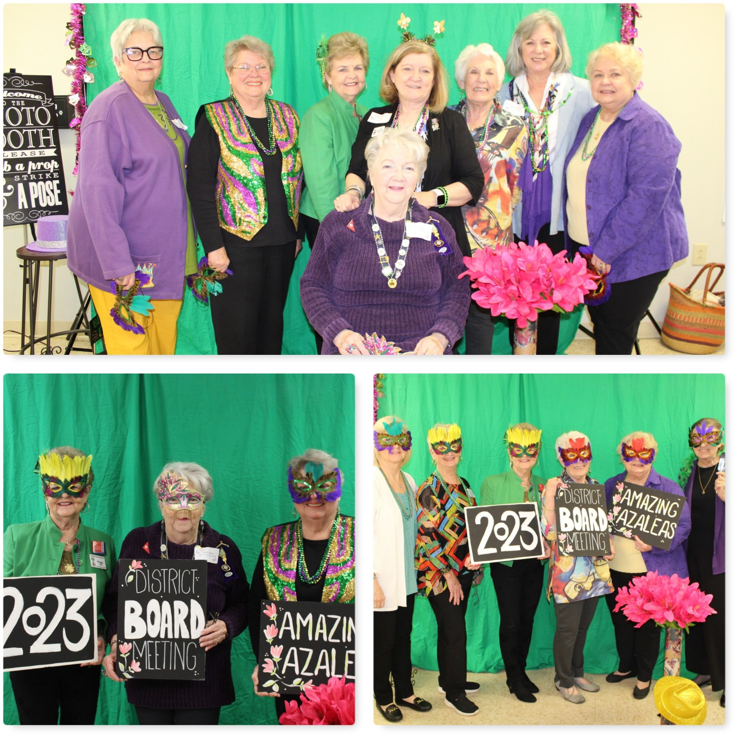

Top: Azalea District Executive members with State President, Peggy Tucker and Past State President, Jane Hersey.
Bottom Left: State President Peggy Tucker, Azalea District Director, Betty Da- vis and Past Ste President Jane Hersey.
Bottom Right: Members of the Pine Tree (Hartwell) Garden Club.

It would be wonderful if we could put ourselves in the dryer for ten minutes, then come out wrinkle free...and three sizes smaller.



Members of Au- gusta Council of Garden Club,
with newly in- stalled President,
Charles Duchscher
More Mardi Gras Madness!


"Laissez les bon temps rouler"

Town and Country Garden Club
Thank you to Pres-
ident, Laura
McNeely and club
members for the fun, fun, fun Mardi Gras
Azalea Board
Meeting in Sand-

Pinetree Garden Club/Hartwell

Augusta Council of Garden Clubs



Top: Iris Garden Club
Center Left: Spade and Trowel Garden Club
Center Right: Rita Hamilton,
Speaker Kerry Mendez and GCG
President, Peggy Tucker
Bottom: Pine Needle Garden Club/Augusta with GCG Presi- dent, Peggy Tucker
Top: Magnolia Garden Club
Bottom Left: Director, Betty Da- vis and GCG President, Peggy Tucker
Bottom Right: ACGC President, Rita Hamilton with Augusta Mayor’s wife, Toni Seals Gar- rett, presenting the Mayor’s proclamation honoring the
ACGC.





U N I O N P O I N T G A R D E N C L U B

Union Point Garden Club, in conjunction with the Union Point Down-
town Development Authority, recently received a $1000.00 grant to continue work on the Joel McRay Memorial Garden begun last year in Union Point

Joel McRay was a much-loved historian in the Greene County area, as well as a Un- ion Point Garden Club member

To receive this grant the project must benefit and have high visibility in the commu- nity, have a high impact and scope for the community, involve participation by
club members, and be in collaboration with other community groups

This project met all the criteria! The Lake Country Board of Realtors got the project start- ed by donating over $8000.00 to put in a hardscape and a kiosk.This included a grant from the National Association of Realtors for $4500.00
Many hours of hard work and physical labor by many volunteers have been going on dur- ing this process and more will happen.
The memorial garden will be along the Firefly Trail, which will be a nonmotorized 39 mile, Rails to Trails multi-purpose path from Union Point through Woodville, Maxeys, Crawford, Arnoldsville, Winterville, and on to Athens in Clarke County
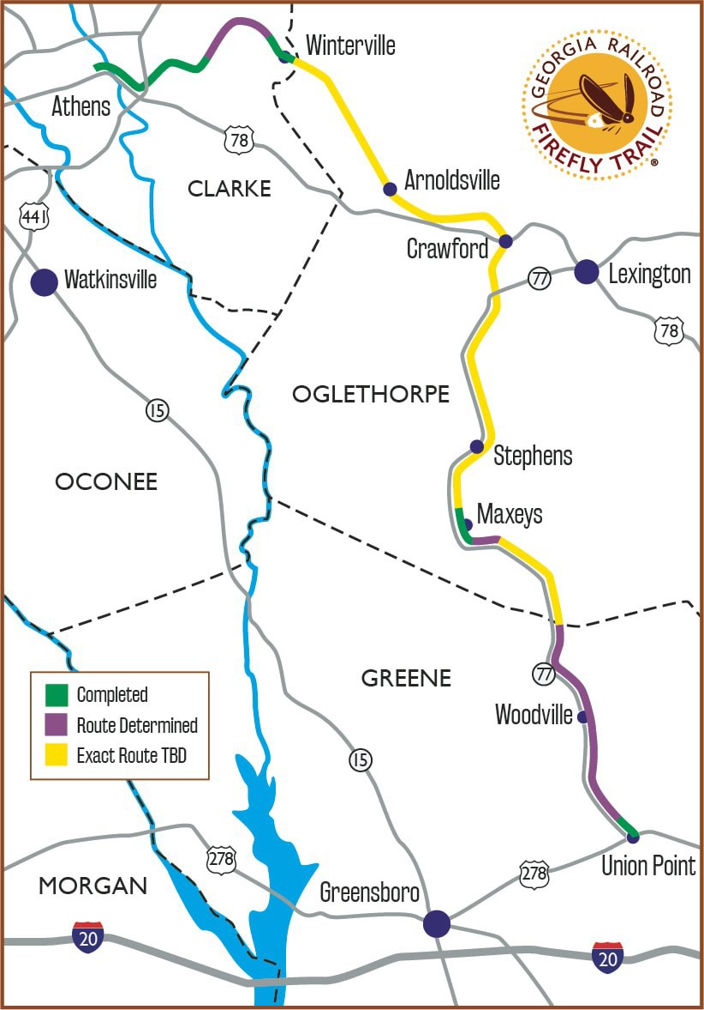
.Model miles are already complete in Union Point, Maxeys, and Athens.Work continues going north from Union Point and South from Athens! Yes,
you can ride your bike, jog, or go for a walk on parts of it right now! If you are interested in helping with or donating to the Firefly Trail project contact Lisa Baynes at lisabfire-
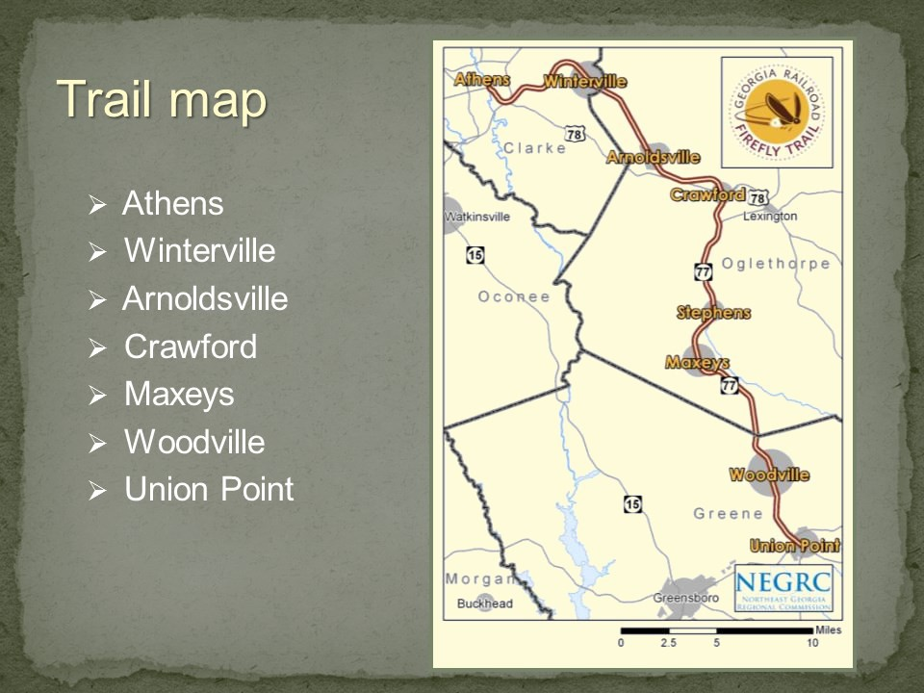


Gray Garden Club
Gray Garden Club stayed busy during the holiday season.
At our annual Christmas party the club do- nated decorated stockings, stuffed with
$1.00, Fig Leaf items and filled a Toys for Tots box to the brim.
The group then redecorated the Fairy
Garden at the J C Library for Winter and concluded December by visiting the Festi- val of Trees at the Macon Museum of Arts
and Sciences.


Trivia Question:
Magnolias were named after which Botanist?
- Peter Mangolian
- Pierre Magnol
- Pierre Nolia
- Charles Darwin

Answer on last page



Ladies Garden Club

Ladies’ Garden Club, Athens steps in to assist the Food Bank of Northeast GA
When the Food Bank of Northeast Georgia (FBNEG) Director approached Ladies’ Garden Club (LGC), Athens to request our involvement in their 23rd annual “Empty Bowl Luncheon” fund-raiser, it was with the idea that LGC create 40 ample centerpieces to both enhance the tables and then be sold to raise additional funds. Knowing we’d have our work cut out for ourselves, new LGC President Rebecca Wood still responded with a resounding “Yes” to assist the good and very hard-working staff and volunteers of this fine organization that now provides critical food assistance to thousands of folks in 14 NE GA counties.
Work began with an in-depth refresher course presented to LGC by long-time member, instructor, and Certi- fied flower judge extraordinaire Celia Fowler, who pushed us to sharpen our skills in advance of tackling this task.
Rebecca Wood created and has run her own pottery-making enterprise, RWood Studio, for over 30 years. She decided to create a set of limited-edition vases to hold our handiwork. Rebecca at her work (r).
The total effort was long and hard for LGC, but with assistance from FBNEG staff supplying us with lots of do- nated flowers, as well as cuttings brought from our own gardens, we plunged in.
Starting with Rebecca’s pottery creations, and adding hours of sorting and prepping, the final result was a

beautiful layout at the March 30th luncheon, and the centerpieces created added almost $2,500.00 directly to the FBNEG coffers. We were immensely pleased and proud of this, and we’ve already been asked to consider returning with an encore effort next year.

(Text by Carol Reap; photos by Connie Herringdine.)
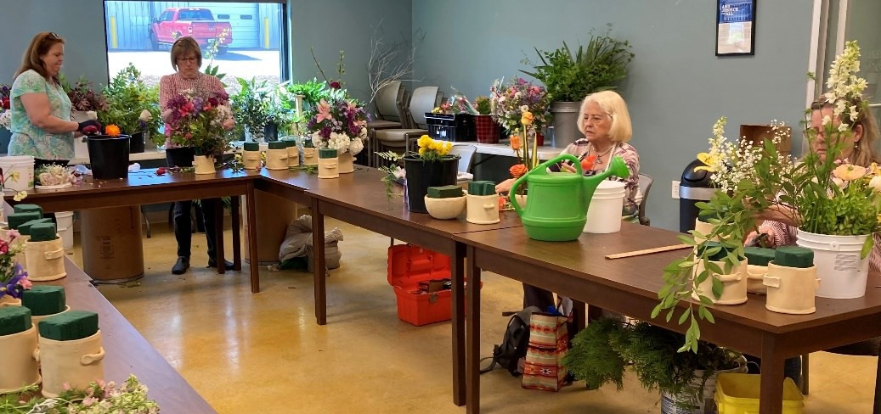
LGC members (l-r R. Lord, C. Reap, C. Fowler and G. Thomason) giving their best effort.


Milledgeville Garden Club

The Milledgeville Garden Club hosted artist, designer and hu- morist Mark Ballard who enter- tained not only Milledgeville
Garden Club members, but Town & Country and Carrington
Woods Garden Club members as well.
He delighted the audience with humor while designing an elabo- rate floral arrangement that was ultimately raffled and won by Terriessa Barman.
Anne Smart was the lucky raf- fle winner of a smaller bouquet.
An array of decadent desserts were provided by members of
all three clubs with Jimmie Spear, Jo Dunn, Ana Edwards, Crystal Law, Ann Vinson and Gi- na Wiggins serving as primary hostesses.
It was a delightful afternoon of fun and fellowship among flower gardeners.

SHARON - RAYTOWN GARDEN CLUB

120 Year Anniversary Celebration

The Sharon-Raytown Garden Club was organized on February 21, 1903. The community of Sharon – Ray- town is located in Taliaferro County Georgia. It is the second oldest continuous garden club in the U.S.A. and remained active through both World War I and World War II.

Miss Lillis Barnett was living in Athens with her friend who organized “The Ladies Garden Club”, the oldest in the U.S.A. in Athens, Georgia. When she returned home from teaching, she organized our Club with twelve
(12) Charter members.

On February 26th, 2023, Sharon-Raytown Garden Club hosted a 120 Year Anniversary Celebration. Here are
a few photos from that day.

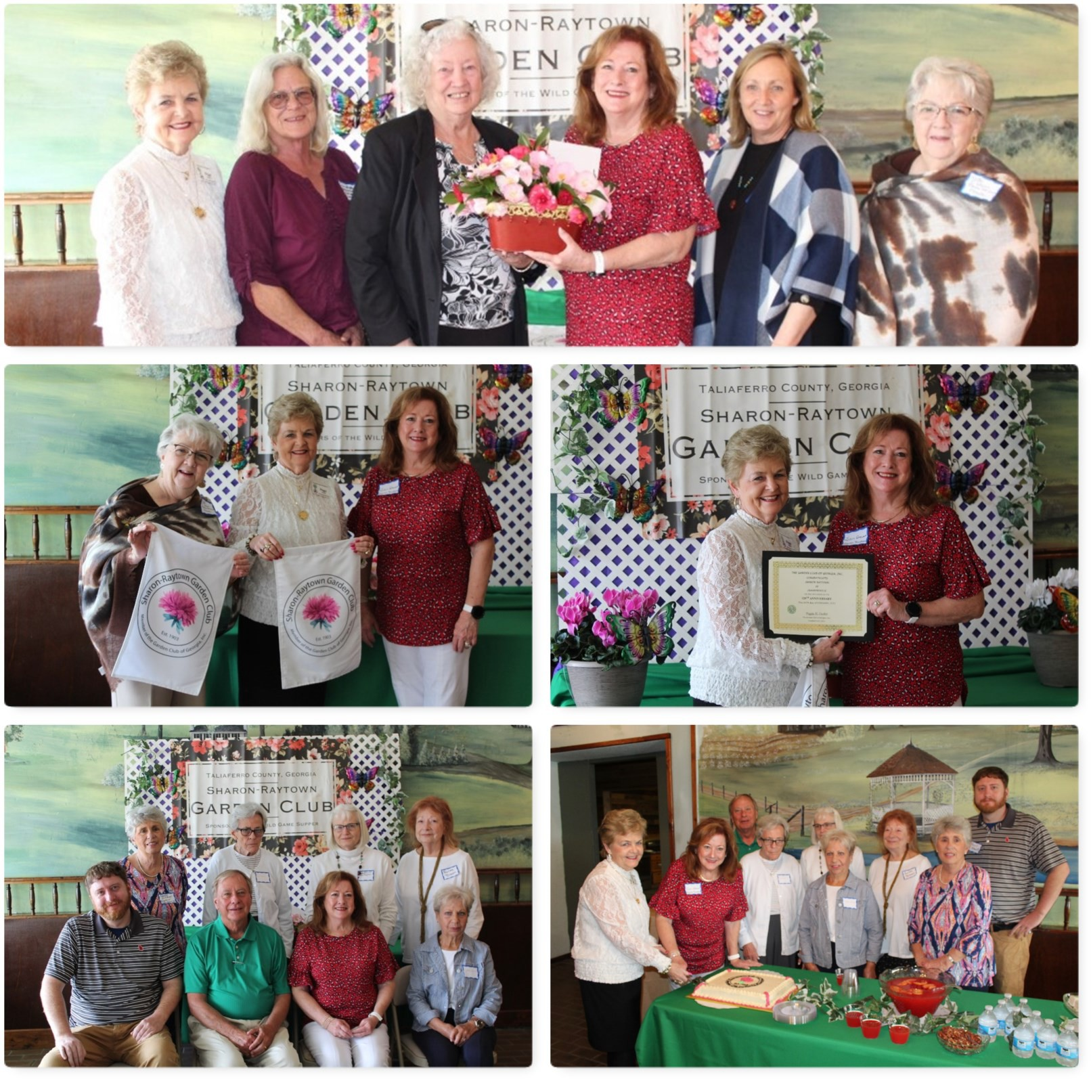Top: Left, Peggy Tucker, GCG President, far right Betty Da- vis, AD Director members of
the Greensboro GC and Jan Stewart, SRGC President.
Middle Left: Jan Stewart, Presi- dent SRGC, presented the “Sharon-Raytown Garden Club” flag to Peggy Tucker, Garden
Club of Georgia President and
Betty Davis, Azalea District Direc- tor.
Middle Right: Peggy Tucker, GCG President, presented to Jan Stewart, SRGC President a certificate to the Sharon-
Raytown Garden Club in recog- nition of the club’s 120th Anni- versary.
Bottom Left: Members of the Sharon-Raytown Garden Club in attendance are.BR: Nancy Sisson, Emily Atchison, Paula Atchison, Renee Brown FR:
Daniel Stewart, Randy Stewart, Peggy Tucker, GCG President and Jan Stewart, SRGC Presi-
Bottom Right: Peggy Tucker, GCG President and Jan Stewart, SRGC President, cut the 120th
Anniversary cake. Members of
the SRGC assisted



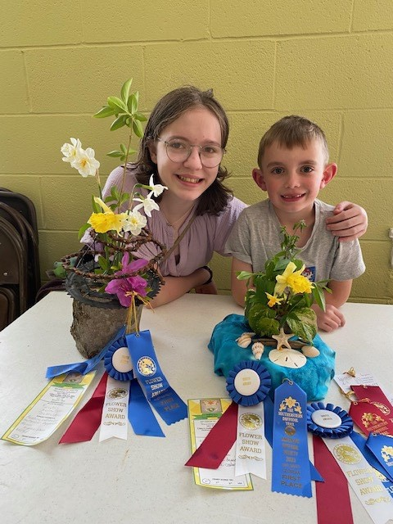
Five youth from Social Circle represented Gateways Garden Club in the youth division of the Southeastern Daffodil Trails Flower Show March 10-11 at The Crown Plaza in Atlanta. The youth that attend came home with many honors. Tri-color Ribbon was awarded to Junior Class - Elijah Dykes with his design “Gather
Watery Wonders” a design that incorporated items gathered along the beach with a clay container with daffodils. The other Tri-color Ribbon was for the Highschool Class - Kaelynn Alley with her design “Hike Till You Bike” she made her container from old bike parts with daffodils in the center. Both designs received wonderful comments from the judges for their creativity.
Others in the show from Social Circle, Intermediate class “Climb Every Mountain” – Lila Crutchfield 1st place with her design of daffodils in a recycled Tennis Shoe. Trey Alley 2nd place with his design of a mountain made from 2 aluminum cans with 2 levels of daffodils. The Highschool class “Hike Till you Bike” Olivia Row-

ley 3rd place with her design using a child bike seat and daffodils enhancing the design.

Elijah Dykes also entered 2 daffodils in the horticulture
class. his daffodil “Marieke” won the Tri-color ribbon and
his James Town daffodil received a second.



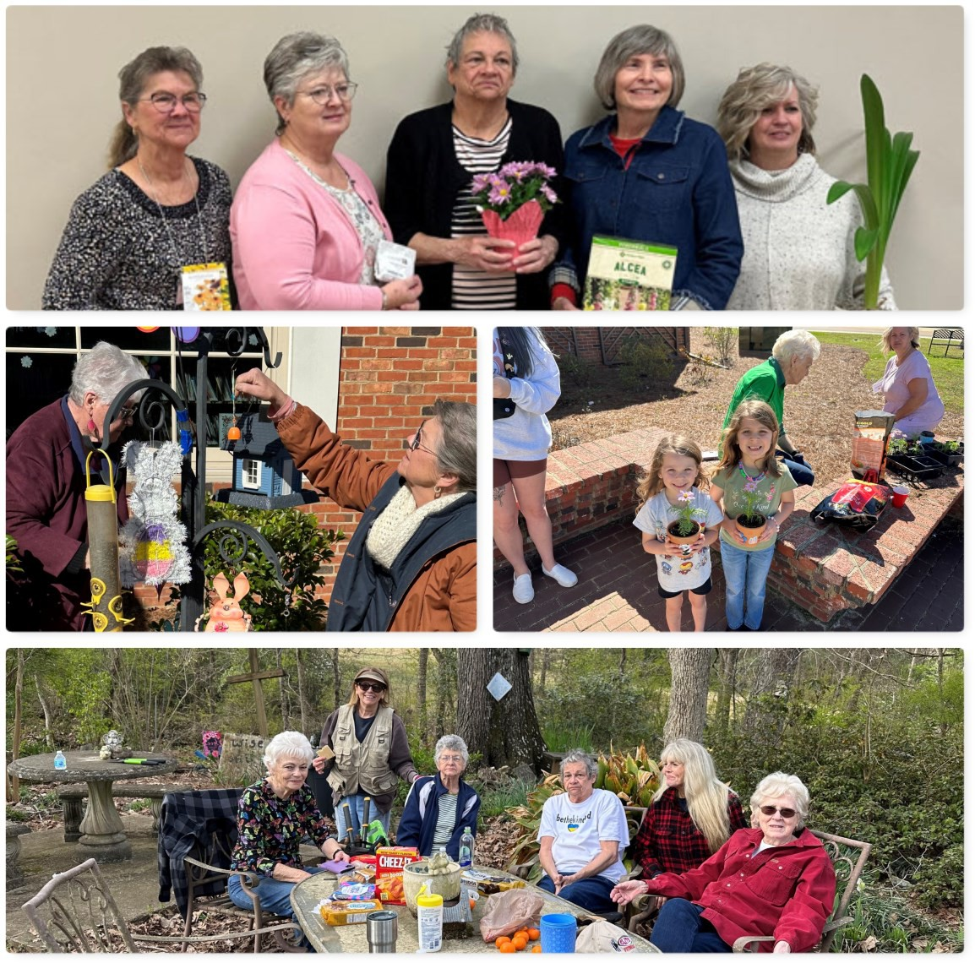
Gray Garden Club
February and March has kept GGC busy!
February was the 2023-2025 installation of new Officers.
In March we helped with a program at the J C Library, “Growing Greyhounds”, by helping Children aged 0-5 plant flower pots, re-decorated the Fairy Garden, at
the library for Spring and helped clean
the Round Oak Memory Garden for their Easter Sun Rise Service



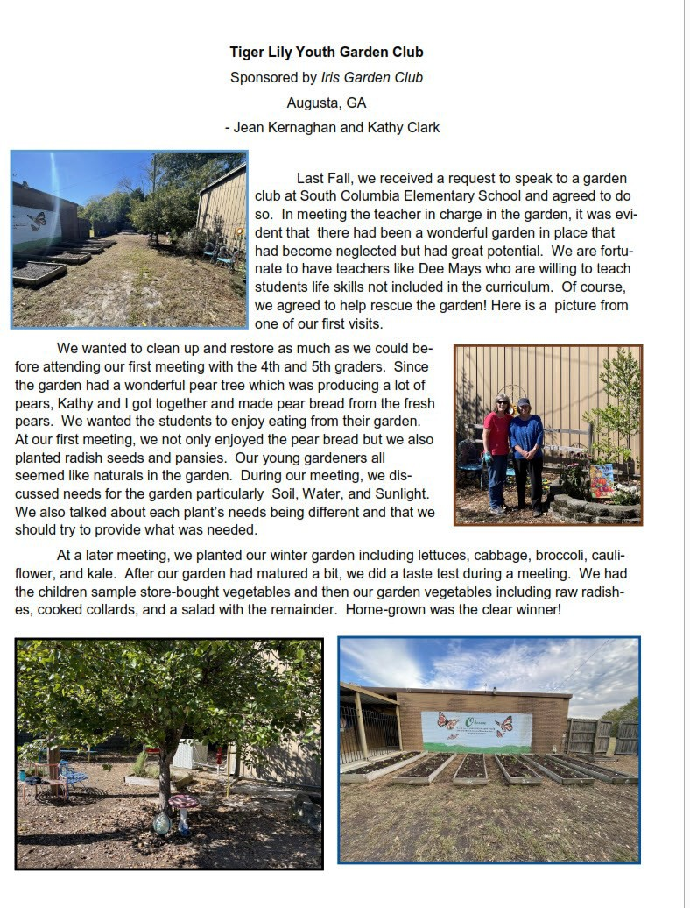
Iris Garden Club



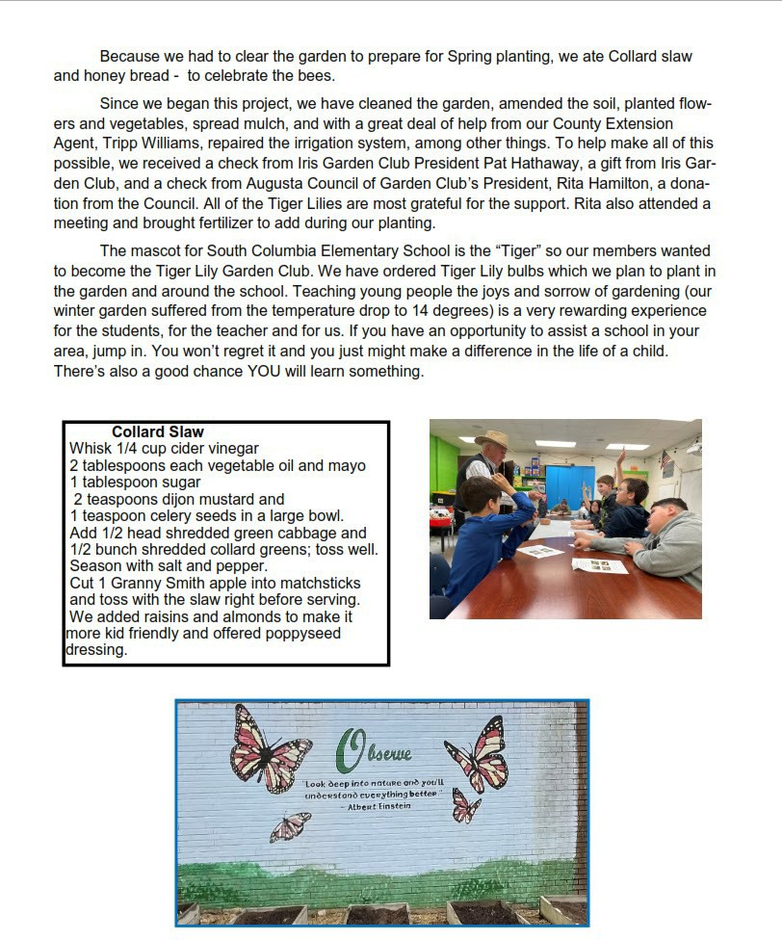

Willow Wood Garden Club

On behalf of the Columbia County Foundation for Children, but most importantly, for the children in our county, I wish to thank you for the recent donations to our Pantry Project.
Generous and continuing support from our community partners like your club is the reason our organization has been able to continue and expand assistance to children with families for almost 30 years. Pantry pro- ject donations are distributed upon request to schools in Columbia County and to families with children up- on referral from school personnel and social workers.
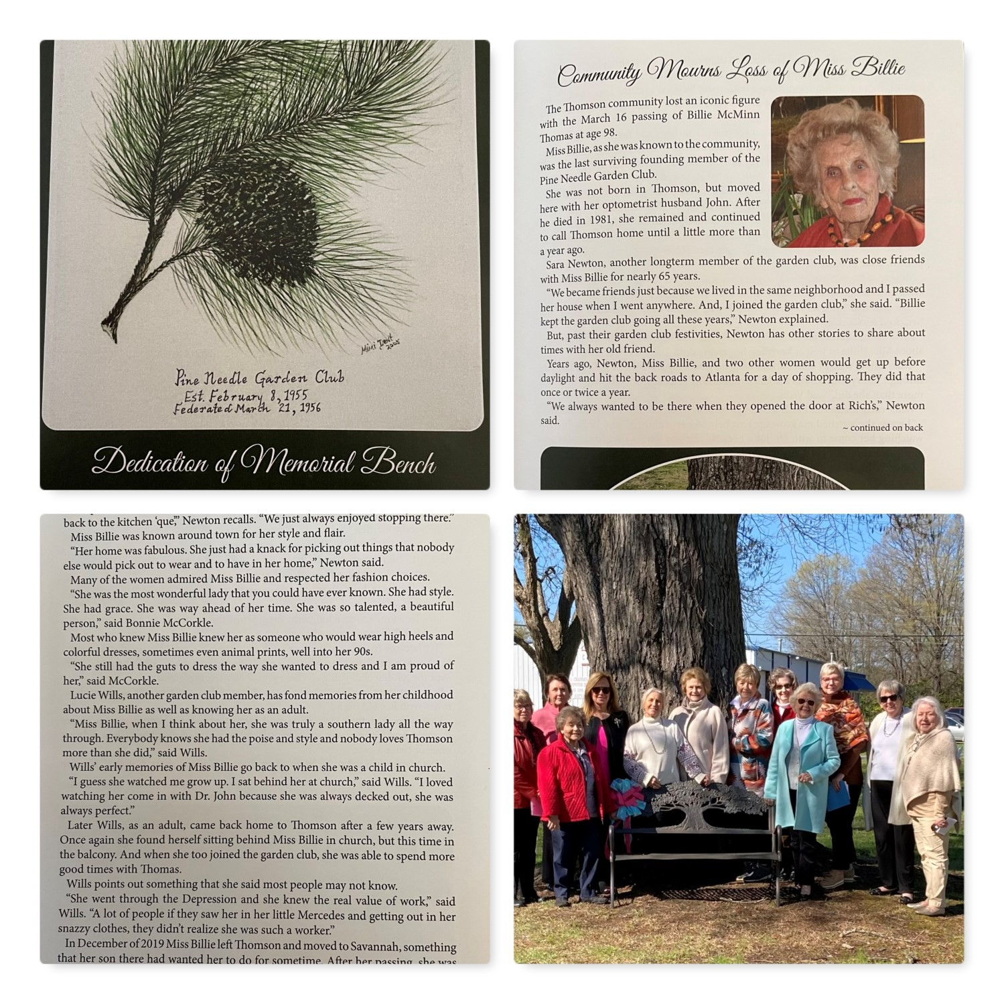Thank you again for your kindness and support for the Foundation. Michel Young (Mrs.), Vice President Board of Directors

Pine Needle Garden Club
Pine Needle Garden Club in Thomson GA dedicated a beauti- ful bench to the community in
memory of Miss Billie Thomson, a founding member. The paper published an article about Billie after her death.
Joanne Anderson, President Pine Needle Garden Club


Announcements


The GardenClub of Geor a,Inc. , 95thAnnual Convention
"<jjaraen :Jlvt.agic on t:lie :Jlvt.ount:ain••
April 18-20, 2023

TheEvergreenLakesideResort • StoneMountain,Georgia
Official Registration Form• Registration Deadline: March 31, 2023
Last Name First Name Badge Harne Preference
City Sta=te Z=i
Phone (w/areacode)

E·mail

ClubHarne
PlEAlHliECKAllTHATAPPLY:
District

•All GCG Board Members, all GCG Life Members and one member from each dub are VotingDelegates; Pleasecheck •votingDelegate• boxif applicable.
0 StatePresident DDistrict Director 0 formerDeepSooth Director
DMember a 0istlictBoardMember □ Deep South BoardII.ember
□Guest □ Council President □ DeepSooth lifeMember
D 'Voting Delegate' 0 formerState President □ formerHational President
□ My first GCGConvention 0 State BoardMember □ National BoardMember
□ClubPresident D StateLffeMember □ National LffeMember

THERE ARE TWO WAYS TO REGISTER(pleasecheck Olle):
J PACKAGEPLAN includesRegistrationfee,Workshops,OpeningDinner, WedLuncheon,AwardsBanquet,
andMembershipluncheon.
PACKAGE PLAN TOTAL ...................................... $256.00 $
Dpart·timeplan• noextrafeeforafternoonworkshops,covered byyour registrationfee
R
P

TuesdayOpeningNightDinner $63.00 | $ | _
WednesdayAwardof Merit Luncheon................................,..... $45.00 | $ | _
WednesdayAwardsBanquet ..............................................•• $63.00 | $ | _
ThursdayMembershipLuncheonandInstallationof Officers...... . . . . .. .. ... . $45.00 | $ | _
EGISTRATIONFErEequiredfor □ Tuesa □Wed N/A for Thurs............... .. $30.00 $ _
ART-TIME PLAN TOTAL......................................................... $ _

TOTALREGISTRATIONCOSTS $ _
late Registration Fee ............................................ (Postmarked afterMarch31stincludeextra$30.00) $ _
TotalEnclosed . . . . . . . . . ................................................................. $ _

SpecialDietaryNeeds:

Make Check Payableto:GCG 2023 CONVENTION
MailCheck &Registrationformto: TrudyRudert,4852ScottsMillWay,PeachtreeComers,GA 30096
TRudert@comcast.net 404-713-6934
No Refunds After April1, 2023 • Registration Fee Not Refundable On•LineRegistrationwill be availableinJanuaryonour GCG website-acceptingpaymentby credit card.





Hotel Reservations: Share with your club members
Way to register:

Online-click here to register: https://book.passkey.com/e/50303356 2023 GCG Annual Convention
Evergreen Lakeside Conference Resort
4021 Lakeview Dr, Stone Mountain, GA 30083

You can come early or stay later for the same discounted rate of $144 +tax+fees, which includes entrance to the Park, normally a $20 fee. Bring your family/spouse.
****If you need special accommodations, handicapped rooms, etc. After you make your reserva-
tions on-line, THEN contact our GCG Convention Coordinator, GERI SHAW, and she will handle making those arrangements with the proper person at the hotel to make sure everyone is happy!!!. LOL "Geri Shaw" <geri.shaw01@gmail.com> She will need your hotel confirmation number, dates of stay, etc.

We hope many of your club members will be joining us for the festivities- always more fun with a group. Great Vendors for your shopping pleasure. Tentative jam-packed Schedule and Speaker info is also attached so you can plan. Please note the schedule - District Officers will be in- stalled during the cocktail hour on Tuesday. District Photos will be taken during the cocktail hour on Wednesday. Register for the full package, or each day. Tues and Wed have registration fees of $30 per day. No registration fee for Thursday - only pay for your meal.

We look forward to seeing you in April.

Your Dogwood District Convention Leadership Team





August 18th and 19th, 2023 The Monarchs are Coming!

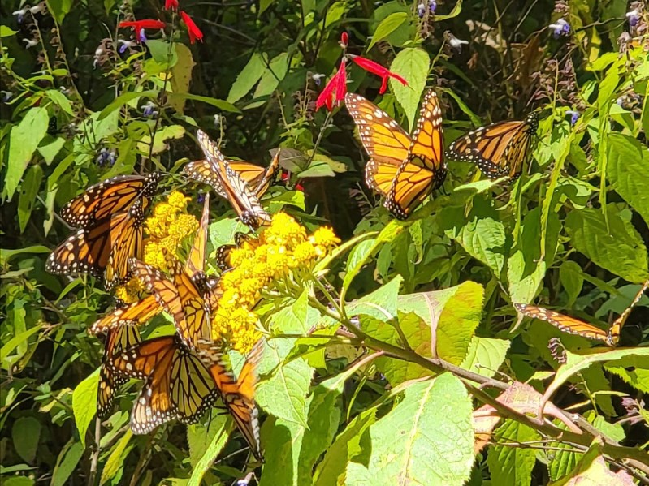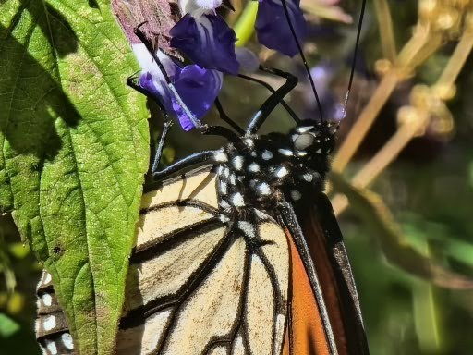

Photo from Santuario de la Mariposa Mon- arch "El Rosario"
Monarch sipping nectar from one of the many wildflowers of the oyamel forest.

If you are a monarch enthusiast, consider participating in Monarchs Across Geor- gia's symbolic migration project. It is open to participants from any state.

Join us on our social media channels, Southeast Pollinator Census Facebook page and @SoutheastPollinators Instagram, Visit our website, https://GSePC.org, for ideas on learning about and celebrating pollinators.

South Carolina, North Carolina, and Georgia are truly making a difference for mon- archs, one garden, and one count at a time,

Becky Griffin
Project Coordinator beckygri@uga.edu




Welcome to Your New, Constantly Evolving Website

We hope you like our efforts. Our purpose is to make a site that promotes all of our amazing garden clubs’ efforts and to make it easier for you and your members to get the information they need on a daily basis. We’ve simplified the navigation while having most everything you’re used to online and updated.
We are continuing to tweak the site and update photos. We’re also determining just what “archives” we want to have available. Our District Pages are going to be the heart of our effort and are being developed with the input of our DD team. The biggest change is the domain name. En-
ter www.gardenclubofgeorgia.org. Yes, our very own domain!
Our home page will be updated with newsworthy tidbits. Don’t forget to register online for the con- vention. And a fillable President’s Report is linked there and in several other places on the site.
Let’s take a quick walk through,
About Us – Our particular history, Headquarters House, Founders Memorial Garden and, of course, a bio of Peggy.

Events Calendar – Keep up with events with our searchable calendar. You can select events by your district, by event, by month. Entries have links to mapping, and the ability click into pertinent websites. There is so much capability here that we’ll be doing separate guidelines for submitting information. And, by the way, you can send events to your own google calendar!
Projects and Programs – There are two ways to get this information. Either click directly on the Main Projects and Programs page where you will see all projects and programs grouped by func- tion -- Community Support, Education, Grants and Support GCG. You can also go directly to the program you want by selecting from the drop-down menu.
News – This is a news blog. We’ll need your help for this. When your club has a significant event, write up a paragraph or two and send it to us. We’ll be happy to upload to the website. Don’t for- get the photos! In the future, this is where you’ll find articles on the convention, awards, anniver- saries, blue star marker dedications, etc.
Membership – You’re used to our forms page from the old website. We’ve taken that one better and put everything you need as a club member or officer. Click on Membership on the top menu bar, or you can use the drop-down menu. We’ve taken the GCG Guide and pulled it apart to put the general information up front-- no password necessary. We’ve got all the forms you need to run your club, make reports, apply for awards, register for events, etc. The people portion of the
Guide is password protected (use grow1315 to get in).
Over the next months, you’ll see even more neat features. But, right now, have fun and let us know what you think. And, please, let us know about broken links, misspellings and anything you miss (Chris Adams, Webmaster, cadams30041@yahoo.com, or Diane Hunter, drmchunter@yahoo.com) Did we mention that site is now searchable? Try it out if you’re having trouble finding anything.
Chris Adams Diane Hunter
And the entire Technology Committee Diane C. Hunter




NGC awarded 53 Plant America Grants.

Of the 53 Grant recipients, 22 were awarded to the Deep South Garden Clubs,
LLC, 9 were awarded to
the Garden Club of Georgia and 4 were awarded to the Azalea District!



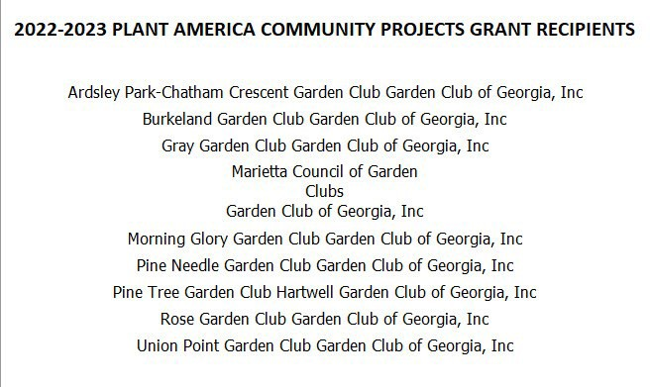


'Rosa[ynn Carter 'Butteif[y Trai[®
2023 Symyosium & Native Pfant Safe
T{ains, (jeorgia
:Jriaay, May 5, 2023

Symyosium Syeakers

Dr. Jaap de Roode, PhD
Emory University Department of Biology Director, de Roode Monarch Lab


Felicity Davis

Georgia Department of Transportation Landscape Architect
GADOT Wildflower Project


Annette Wise
Founder/President of
Rosalynn Carter Butterfly Trail®


Bess Hartley
2nd Vice-President Garden Club of Georgia

Symposium details are located on our website as well as registration information. www.rosalynncarterbutterfiytrail.org
Seating will be limited so book early!

2023 Rosalynn Carter Butterfly Trail: Spring Symposium
Plains Community Center Main Street and Clark Street Plains, Georgia 31780
Registration Form for .Friday, May 5, 2023
A complete agenda and online registration is at www.rosalynncarterbutterflytrail.org
Sponsored ,b: The Rosalynn Carter Butterfly Trait®, Lazy K ursery, and The Garde1j Club of Georgia.Jue.

Full Name Mailing Address

City
State Zip code _

Phone tts cell(
} Home(
) _

Email

Plants you a1re interested in purchasing: _

RCBT: Trail Garden Name--------------- Garden Number ---
If you are re,gistered with the R11salynn Carter Butterfly hail llRCBTl 1/st the name 11( your garden and number,as listed on our web.lite.

Each person attending needs to complete a separate form with payment Registration is $50.00 per person.
Seating is limited so please register early! To register, please tomplete Uiis form onlh1e with p,aymeut or nail your registration forn• and check for 50 made pa. a.Ille to the Rosal rm Carter Butterfly Trail P.O. Box 10, Plains, G. 31780.
Symposium details are online at www.rosalvnncarterbutterflytrail.org. The event will be at the Plains Conumrnity Center in Plains, Georgia. Lunch is included in the registration fee. For additional information c,ontact Annette Wise 229 824-4567 or Willie MaxweU 229-938-5830.
Lunch choices include a bo.xcocl meal with a sandwich, chips, dessert and drink or a garden salad.

l.P]ease mark your choice Sandwich choice:
Ham
Tmkey !!! Garden Salad

salad dressing choi.ce:
2.Drink: Water Coke Diet Coke

8:30AM Reg1stration Plant Sale and Silent Auction 9: l5AM Wek,ome
9:30A.M Speake programs
Ranch Ital.ian Thousand Island

1:30 Closing Remarks- Silent Auction Winners Announced and Door Prizes
eed wap (optional)- Bring a packet of homegrown seeds and swap for one you want (label yom seed packs!) Silent Auction - Bid on items in the auction frorn 8:30AM - I :00PM

All profit made from the Silent A rcti01:i and Rosafym1Caner B1,ttle1jl_yTrail plants/items will go directly to establish additional habitat for pollinators and promote the Ro.salym1Carter Bu!ferfly Trail.

Restored Clean Water protections come to Georgia, but may not change Okefenokee
mine
By Marisa Mecke, Savannah Morning News,
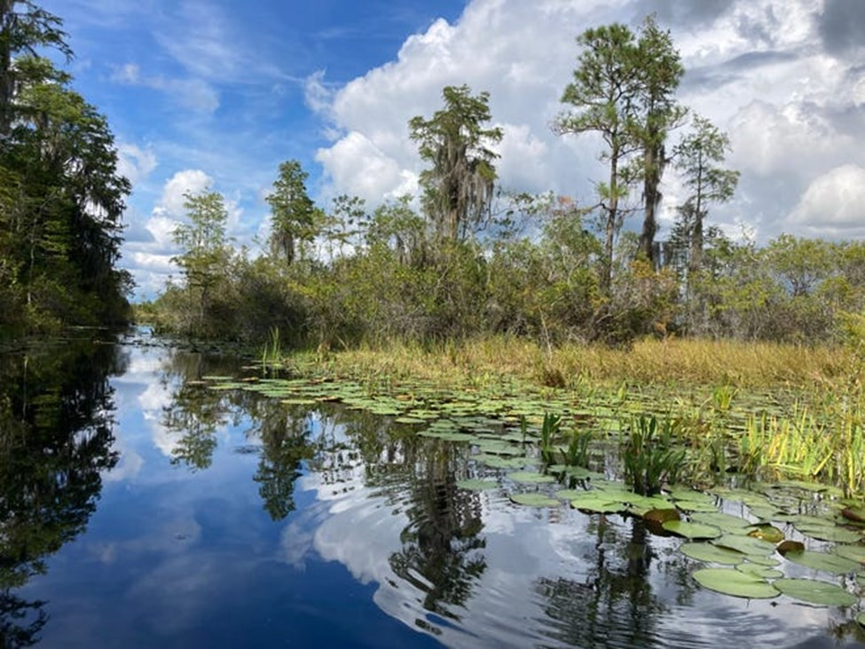

On December 30, the Biden administration restored Clean Water Act protections from pre-2015 af- ter years of rough legal waters. The new rule, recently announced by the U.S. Environmental Protec- tion Agency and the Army Corps of Engineers, reverses a Trump-era rule that scaled back protec- tions and excluded some critical wetlands and streams from protection.

Whether it is developers looking to construct near a river or a company looking to discharge its waste into a waterway, there are plenty of ways that local actions — like applying for a permit, in these cases — have bits of state and federal water protections baked into everyday work. In Georgia, the legal battle over wetlands protections not only impacts regular development but has centered the federal flip-flopping at the site of the controversial proposed titanium dioxide mine at the Okefe- nokee National Wildlife Refuge.

Current clean water policies find their origins in WOTUS: Waters of the United States. A 2015 Obama administration rule, WOTUS defined what waters can be protected under the Clean Water Act, and the Biden administration's rule looks to set the clock back to before that 2015 decision. The
need for a change came after major upheaval in water protections during the Trump administration. In 2017, the Trump administration started unwinding Clean Water Act protections with the Naviga- ble Waters Protection Rule, which reduced or removed protections from millions of miles of streams and wetlands. It went into effect in 2020.But in August 2021, a federal judge in the United States District Court for Arizona struck down the rule, citing the potential for environmental harm, viola- tions of the 1972 Clean Water Act and hundreds of projects nationwide that went ahead without en- vironmental permitting where it previously would have been required."

"When Congress enacted the (1972) statute, it wanted to protect the aquatic ecosystem: all the streams and wetlands that are necessary to make sure that our rivers, lakes and drinking water sources are safe, and people can fish in them," said Kelly Moser, a senior attorney at the Southern Environmental Law Center (SELC), a regional nonprofit legal organization that employs lawyers, policy experts and community advocates to challenge environmental threats. She said that the rule was based on scientific evidence that waters that may not touch a river still have big environmental impacts, like wetlands that protect communities against flooding, which Trump's rule doesn't ac- count for.
While the new rule will increase and re-solidify watershed protections, an upcoming U.S. Supreme Court decision could dampen, or effectively wipe out, the EPA's new rule. Sackett v. EPA is a case brought from Idaho regarding filling federally protected wetlands near a large lake and the scope of the Clean Water Act that was heard in October by the highest court in the land and will deliver a de- cision this year.
Some worry a conservative-leaning court will deliver a huge blow to the Clean Water Act, just after its 50th anniversary, and that the EPA's new rulemaking was futile. But Moser at the SELC said that putting the EPA rule in place now means the agencies will likely have some room to interpret the decision and the context of their rule. She said that the EPA attorneys have sent a copy of the rule to the U.S. Supreme Court to review and see how the rule is rooted in the text of the Clean Water Act.

There's a bit of irony that the Okefenokee — which in the language of the region's indigenous group, the Muscogee, means "land of the trembling earth" — has its future on shaky legal ground. The changes in federal protections have overlapped directly with the proposed mining project, causing the U.S. Army Corps to deliver and take back federal protections over the summer. But the new rule change won't stymie the contentious development.
Twin Pines Minerals LLC, the company aiming to open the mine, declined to comment for this sto-
ry.



House Bill 71 has been introduced - with bi-partisan
support: The Okefenokee Protection Act
The Okefenokee is one of the greatest remaining natural treasures in the world and holds significant economic, ecological, and cultural value for
the people of Georgia. We cannot risk long-term damage to the swamp for an experimental, unsustainable mining project. Now is the time for state action to protect this national treasure. Opponents of mining near
the Okefenokee want to prevent permanent damage of the swamp’s abil- ity to hold water. Twin Pines officials argue mining will have minimal impacts.
C. Rhett Jackson, professor of water resources at the University of Georgia, described the mining plan as “deeply flawed.” He said mining will make droughts more frequent and severe in the eastern portion of the swamp and increase the probability of wildfires.
Garden Club Members - share this with your friends & neighbors. Ask everyone to call or write to their legislators -
The Protect Georgia link is the easiest way you can contact your legislators who are now in session under the Gold Dome. Fill in your info and edit the sample letter as you wish. It will be sent to your State Senator and State Representative.
www.protectgeorgia.org/okefenokee






•• ••••••••••••••••••••••••••••••••
•• WIN WIN WIN •

- $ $
•
- GCG
$ $ $ $ s $ $ $ ••
CASH RAFF'LE ••

••
••
•

•

•
•
•

••

•••

The Garden ,Club of Geor,g-ia.. Inc. wm have a Cash Raffle again this year (2022-2023} as its o,nly fundr,aiseir..G,arden club memlbers from e.a,ch district are encourag,ed to ip,articipate and suppo,rt this fundraising effort.

!Each IOiistrict has been given tkkets to s,ell. As an innmtiv,e to s,eU thelr tickets, a $250 bonus will be given to each district that seUs 3.50 tid ets.
Addit onal tickets will be availab,le.

Both garden club m•,embers and n,o,n-members m,ay participate in th,e mflle

C,ost ol Tickets: $5 eaeb or s lor $20·
Ca1sh Prizes to be give.n at the 21023'Con·vention

$500 first prize
.$ 250 seco,nd prize

.$ 125 thiird prize
YOU DO NOT.HAVE TD 8.E PR'ESENT AT THE DRAWING TO WIN
••
••
•

••
••
••
•
•

•••
•••
•••

••••••••••••••••••••••••••••••••




Azalea District Calendar 2021 – 2023

April 14-15, 2023 NOGS Tour of Hidden Gardens Savannah April 16—22, 2023 Garden Week in Georgia
April 18—19, 2023 GCG Convention Stone Mountain April 23—25, 2023 Flower Show School II Marietta May 2—5. 2023 NGC Convention Greenbrier, White Sulphur Springs, WV May 2023 The Rosalynn Carter  Trail m s
June 4—10, 2023  June 30, 2023 | National Garden Week  DEADLINE FOR SUMMER AZALEA TRUMPET
Aug. 27—30, 2023 | Flower Show School III | Marietta
September 30, 2023 | DEADLINE FOR FALL AZALEA TRUMPET
November 2023 | HLP Fundraiser Massee Lane | Ft. Valley
November 30, 2023 | DEADLINE FOR WINTER AZALEA TRUMPET
Feb. 24 —28, 2024 | Flower Show School IV | Marietta


Trivia Question Answer:
Magnolias were named after which Botanist?
B. Pierre Magnol

